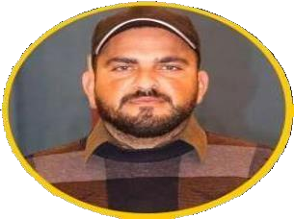

**BS SOFTWARE ENGINEERING**

NUML University 2017-2021

**ICS**

GOVT. DEGREE COLLEGE KAHUTA 2014-2016

**MATRIC**

GOVT. HIGH SCHOOL BEOR 2011-2013

**Address**

H No 211 Railway Line Gulzar.e. Quaid Airport Link road Rawalpindi

**Phone**

0336-9218845, 03045100842

**Email**

[Zeshan90054@gmail.com](mailto:Zeshan90054@gmail.com)

**SOFTWARE SKILL**

**CONTACT**

**WORK EXPERIENCE**

**ABOUT ME**

**EDUCATION**

**ZESHAN** RABNAWAZ

W E B D E V E L O P E R

To achieve excellence in career through constant struggle and work in a goal-oriented environment and contribute positively in IT profession. Like to be part of a company that can provide more challenging and rewarding careers that should sharpen and enhance my knowledge and skills.

**01/04/2023-Present Jr. Laravel Developer**

## Accrual Hub Pvt Ltd

Backend Developer in Laravel, making Product base and Service base Projects. Developed the web application using HTML CSS3, Visual studio, SQL Server, Bootstrap, HTML5. jQuery and JavaScript.

# 01/08/22-01/04/23 BACKEND DEVELOPER

## PK TEAMS

Backend Developer in PHP Laravel, making Restful API with Product base. Making and manage API though Flutter and React base product and Project. Pure API Development using Laravel with MySQL Database.

# 01/02/22-01/08/22 Web Development

## SPEEDFORCE DIGITAL

Experience about Editing and Updating the CSS files. Developed the web application using HTML CSS3, Visual studio, SQL Server, Bootstrap, HTML5, jQuery and JavaScript.

HTML5, CSS3 BOOTSTRAP

CORE PHP LARAVEL Restful API

MYSQL JAVA SCRIPT